**iPear Network Diagnostic Tools User Guide**

1. Download the following files from this [link](https://github.com/ChoiTommy/EE3080-Cyber-Attack-and-Defence/raw/main/Attack/NetworkingTool.tar.gz).
2. Save them to your desktop.

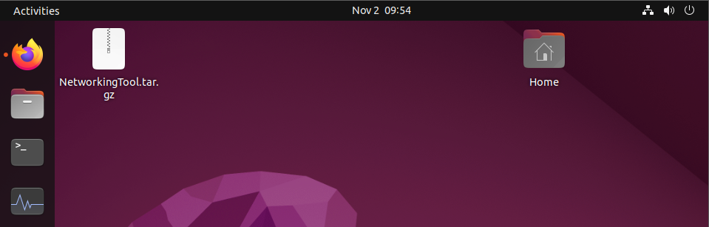

1. Unzip them to the Desktop folder.

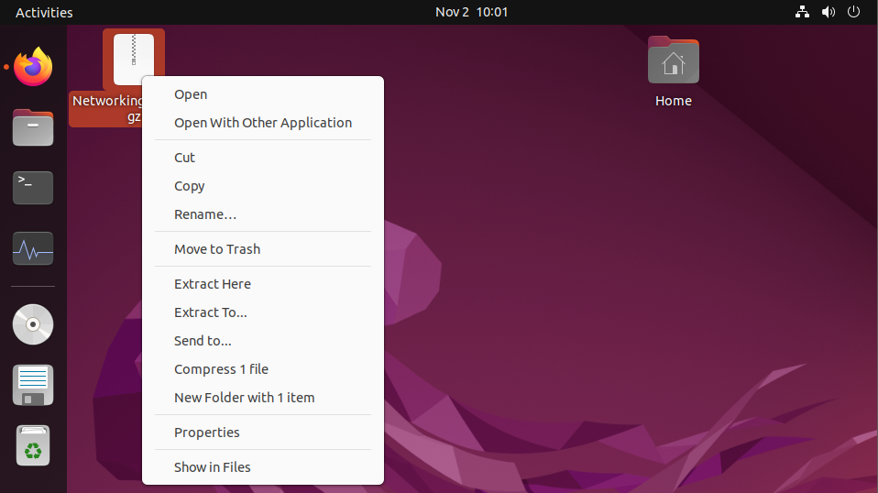

1. Right click on the NetworkingTool.desktop and click “Allow Launching”.

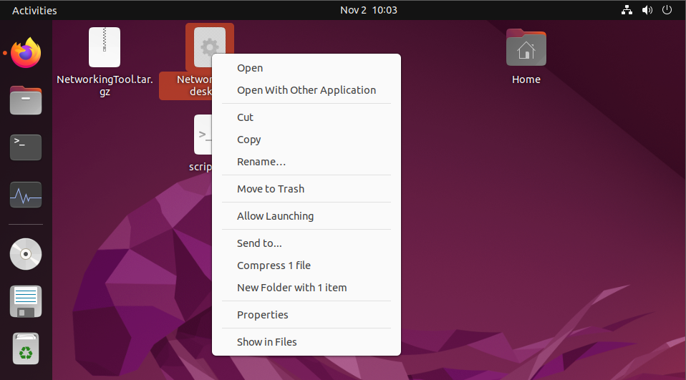

1. Double click on the NetworkTool.desktop icon to run it.
2. It will detect the networking problems you have and fix those for you. Sit back and wait for it to finish.

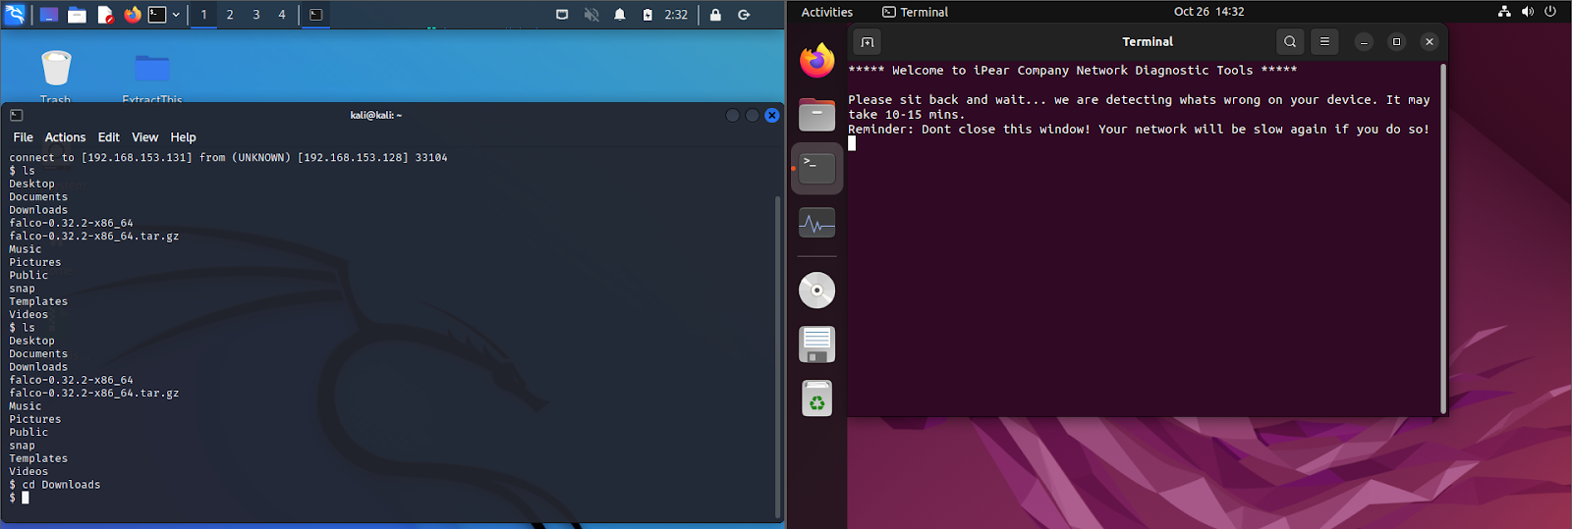

1. If the networking problem persists, kindly approach our staff in the IT services department.